Processes and signals

ex.: 3 processes that perform 200 iterations each => 200 -> 600 total iterations (race condition)
when we syncronize:
- starvation
- deadlock
- livelock

open fopen
lseek fseek = positioning inside the file
close fclose
(read about c functions in working with files)

SEEK:
← SEEK_CUR → (from curr pos)
SEEK_SET → (from begnining of the file)
← SEEK_END (from end of the file)

When calling open/fopen a new object is created in the kernel space and we access it by a descriptor.
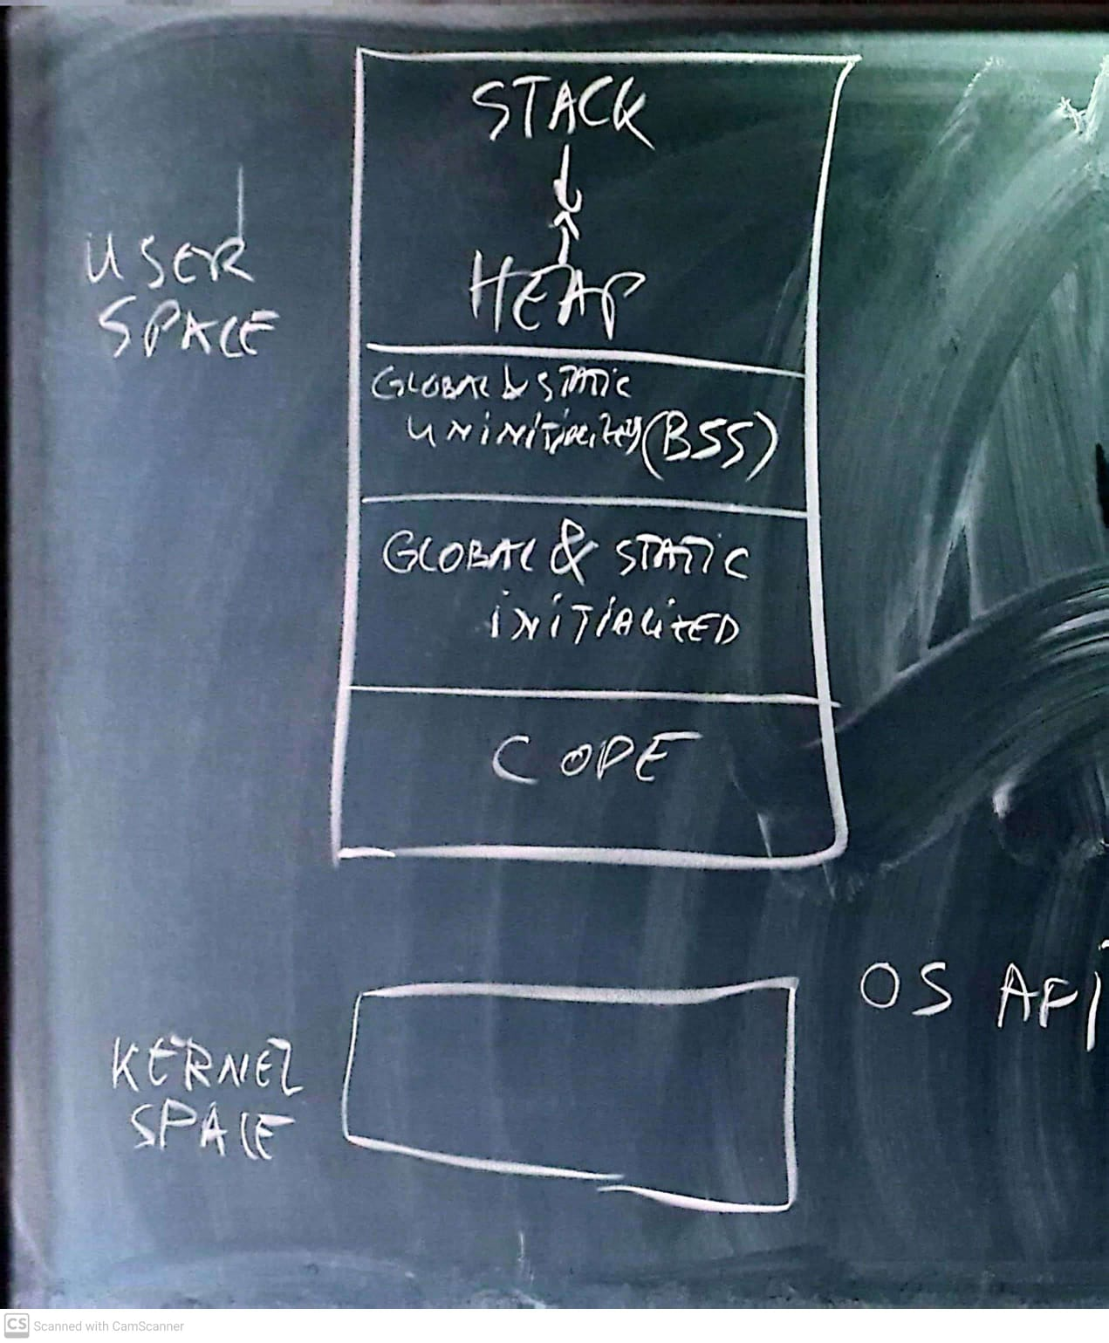

When calling fork → a copy of all the user space is copied and it is a assigned a process id (int > 0), if it could not be created → -1 (= not child process).

#include <errno.h>
// block of code
perror(“…”) //→ display the corresponding error message

wait() = the parent waits until it receives a signal from the child that it finished

exit() = notify the parent it finished

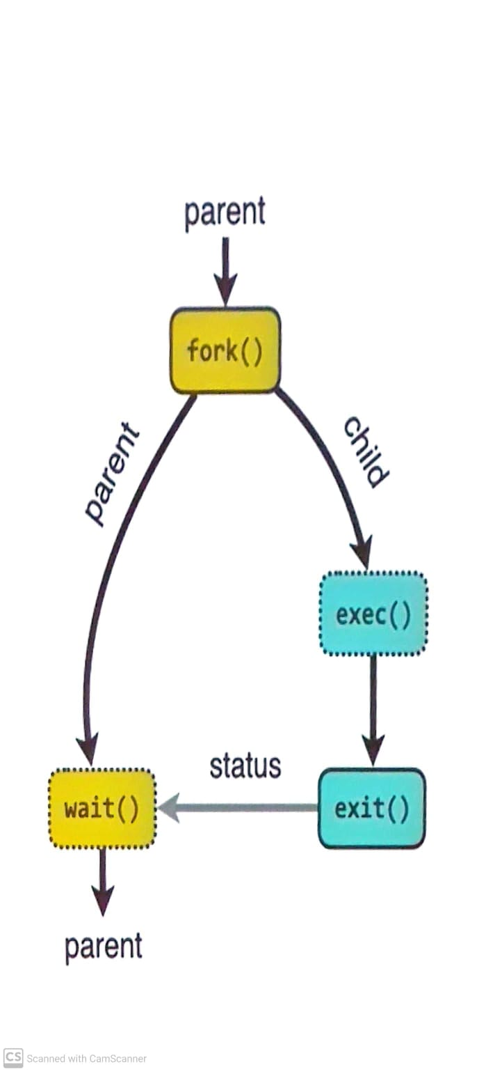

fork();
...
wait(&status);

if (WIFEXITED(status) > 0) {
exit_status = WEXITSTATUS(status);
printf(“%d”, exit_status);
}

IPCs

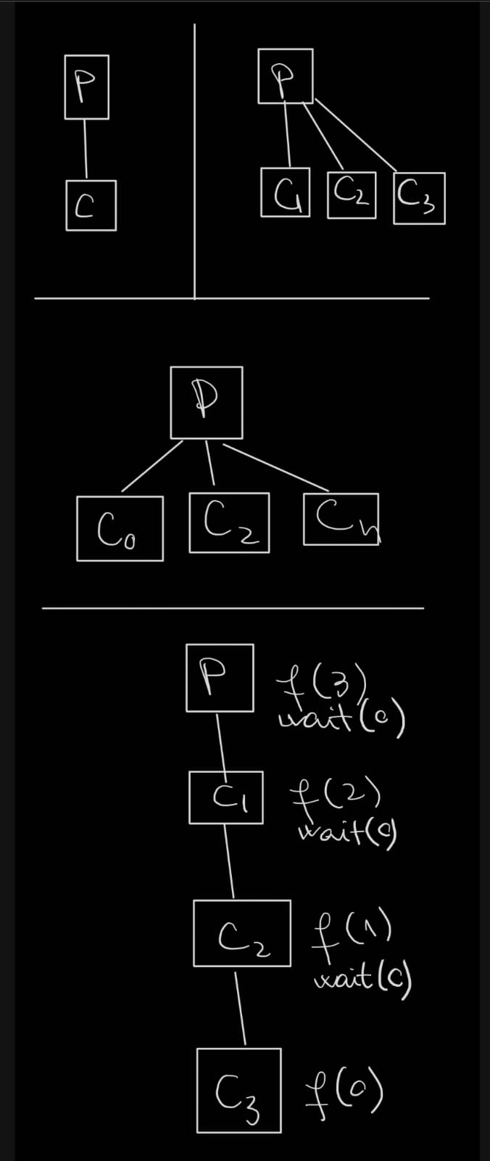

Ctrl+c = SIGINT (sig interrupt)

kill() = send a signal to terminate
signal() = attaching a routine to a signal, not sending a signal

Ctrl+z = SIGSTOP

SIGTERM (if we don’t specify any signal) (“kill()” → “kill(SIGTERM)”)

signal (<semnal>, <attached_slot>)
kill (<pid>, <signal>)

exec → discard all the code after the call and execute the given program

